Algebra 1 Name: _________________________
Working with Two Categorical and Quantitative Variables Date: ____________________

There are essentially two types of data:

1. ______________________________ 2. _____________________________

Quantitative Data
- Examples: age, years of schooling, height, weight, test scores, etc.
- Displayed by box plots, dot plots, histograms
- Represented by mean, median, and mode as well as frequencies

Categorical Data
- Examples: color, type of pet, gender, ethnic group, religious affiliation, etc.
- Displayed by bar graphs and pie charts
- Represented by frequencies

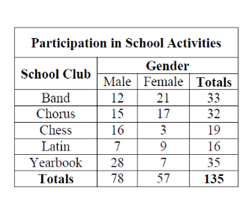
______________________________ is a useful tool
for examining relationships between categorical variables.

1. How many males are in the chorus? __________
2. How many females are in Latin? __________
3. How many students are in the Chess Club? __________
4. What is the total number of females? __________
5. What is the total number of students in the clubs? __________

______________________________ an entry in the body of a two-way frequency table.
______________________________ an entry in the "Total" row or "Total" column in a two-way frequency table.

Gender | Preferred Sport
 | Baseball | Soccer | Basketball
Male | 49 | 52 | 16
Female | 23 | 64 | 33
Example

a. What is the joint frequency of male students who prefer soccer? __________

b. Which marginal frequency is the largest? __________

1. Sixty-six freshmen responded to a survey with 32 saying that they would be attending the school dance. Of the 84 sophomores that responded, 46 said they would attend. Organize the data into a two-way table and answer the following questions.
Class | Attending | Not Attending | Totals
Freshman
Sophomore
Totals

Class | Attending | Not Attending | Totals
Freshman | 32 | 34 | 66
Sophomore | 46 | 38 | 84
Totals | 78 | 72 | 150

a. How many students responded to the survey?
b. How many of the students that were surveyed were attending the dance?

c. How many of the surveyed sophomores are not attending the dance?

d. What does each of the joint frequencies represent?

e. What does each of the marginal frequencies represent?

______________________________ takes the data in a frequency table and converts each entry to a percent of the total.
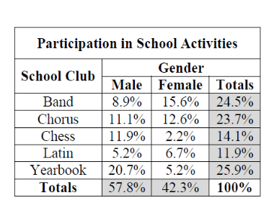
Two-Way Frequency Table Relative Frequency Table

How do you calculate these percents?___________________________________________________________

2. Create a relative frequency table for the following data.

Class | Attending | Not Attending | Totals
Freshman | 32 | 34 | 66
Sophomore | 46 | 38 | 84
Totals | 78 | 72 | 150

______________________________ the percent or ratio of occurrences of a category given the specific value of another category.

3. Let's construct a conditional relative frequency distribution given the number of students responding to the survey with regard to class totals.

Class | Attending | Not Attending | Totals
Freshman | 32 | 34 | 66
Sophomore | 46 | 38 | 84
Totals | 78 | 72 | 150

Class | Attending | Not Attending | Totals
Freshman
Sophomore

4. Let's construct a conditional relative frequency distribution given the number of students responding to the survey with regard to attendance totals.

Class | Attending | Not Attending
Freshman
Sophomore
Totals

Class | Attending | Not Attending | Totals
Freshman
Sophomore
Totals

Class | Attending | Not Attending | Totals
Freshman | 32 | 34 | 66
Sophomore | 46 | 38 | 84
Totals | 78 | 72 | 150

Class | Attending | Not Attending | Totals
Freshman
Sophomore
Totals

Class | Attending | Not Attending | Totals
Freshman
Sophomore
Totals

